An interactive mobile application as a digital learning aid which has a significant impact on learning in project management.

Preface

This report summarizes the evaluation and reflection of our digitalization project. It includes a short literature review on digitalization projects, a self evaluation of the final product, an evaluation whether it was a success or a failure and a summary of the most important lessons learned from the project.

Group number: 22

Student names and student number:

1. Bobeau, Antonin - 519277
2. Kaandorp, Paul - 520010
3. Keller, Jonas - 519301
4. Namink, Susan - 519125
5. Verhoijsen, Jessica - 519366

# Digitalization projects

# A.

At the end of this project, a mobile application (app) will be delivered. This application is targeted at master students and future project leaders. The goal of this application is to introduce the concept of project management, and create understanding what project management entails. Furthermore, the app will introduce fundamental project management terminology and focus on the required teamwork and its importance during a project. This focus will hopefully encourage the end-users to work together in an early stage, and help them to develop an important skill set that can be used throughout their lives and careers. In addition to providing the end-users with project management information, the app will provide tests in the form of quizzes to the end-users. Therefore, the users can test their knowledge and identify which elements of project management need further attention. The users will learn about project management in an interactive, modern way.

# B.

A digitalization project is a project which aims at increasing the use of digital or computer technology by for example an organization, industry or country. Digitalization project are complex and require effective project management (Lopatin, 2006). Factors that should be taken into account in digitalization projects are the management of budgets, staffing, determination of technical specifications and metadata creation. All these factors are important for a successful digitalization project. Literature provides several guidelines for managing digital projects. For example Chapman (2000) states the three phases of a digitalization project, namely: setting goals, planning and budgeting, and managing workflow. Every phase contains various issues and tasks. Digitalization projects also involves management issues, which can be countered by well organized project planning and resource delivery (Grout et al., 2000).

In our project we also applied the three phases of a digitalization project. We started with the first phase, setting goals. This is an important phase of the project since this phase determines the product we are going to work on. We brainstormed about ideas and finally came up with the application idea. We set some functions and goals that the final product had to meet. After this, we started planning the process. This worked quite well for our group. We had a few meetings during the project and in every meeting we discussed what still needed to happen and we set some deadlines. The last phase, managing workflow was sometimes a bit challenging for the project. It is difficult to find times at which everybody is available, since we all have different schedules and courses. Therefore, we were sometimes forced to work on the application alone. This means that after finishing the whole team needs to be updated about what has been done and what still needs to be done. In addition, team members might have different ideas on how to proceed with the application and it is difficult to discuss this if we are not able to meet frequently.

Since digitalization projects are complex projects, it is important to take into account the generic success factors of projects as stated by Murphy et al. (1974). Examples of key success factors of projects are good coordination with stakeholders, agreed success criteria realistic estimates, adequate project planning and good project start-up processes (Hussein, 2018). To ensure project success the project characteristics like organizational complexity, level of transformation, level of impacts on business, constraints and uncertainties should be analyzed and understood in order to put more focus on critical success factors that increase project success.

In our experience adequate project planning and good project start-up processes were very important in this project. As stated before it was not always possible to meet frequently due to different schedules, therefore we needed to plan well in advance. Also the start-up of the project is important, all member should agree on what we are going to product and be on the same page. Furthermore, the project owners (us) need to be on the same line regarding success criteria, so even when we work on the project by ourselves we should try to achieve the same goals.

# Self-evaluation of the project management effort in the project, success or failure? And why?

First a distinction is made between project success and project management success in order to evaluate whether the project can be considered as a success or failure (De Wit, 1988) (Baccarini, 1999). Project success is defined as the ability to satisfy the overall objectives of the project, which is the effectiveness of the results. For this digitalization project, project success measures whether purpose of the project is achieved as well as whether the end users are satisfied. The purpose of this project is to plan, develop and produce a digital learning aid in project management, which must have a significant impact on learning. This purpose is achieved during the project, since a project plan is developed and delivered. Furthermore, a mobile application (app) is developed for master students and future project leaders. This mobile application introduces the concept of project management and helps them understand what project management entails. This mobile application contributes to a more easy and funnier way of learning. Thus, it can be concluded that these aspects contribute to the project success. However, it should be noted that the mobile application is launched in Norway but developed in the English language. Since the app is not available this could decrease the end-user satisfaction. However, it is assumed that the language is not a problem because the end-users should be fluent in English.

Project management success is another way to evaluate the project. Project management success measures success in terms of performance criteria such as costs, time and quality (Baccarini, 1999). Project management success is thus concerned with the efficiency of the project management effort. This project can be considered as a success by looking at the aspects of costs and time. The mobile application is developed by using free software available on the internet, thus there is no risk of costs. Furthermore, all project owners worked voluntarily on the project and did not receive any compensation during the project. Thus, no costs are involved for the implementation of the product. In addition, all project deliverables are delivered before the deadlines and every project owner executed their tasks according to the project schedule developed in the project plan. By looking at the quality of the app, it can be said that this aspect can still be improved. For example, when the end-users changes to another main category in the app (eg from Home to Quiz or to Schedule) the “progress” is lost. This could be improved but since the app is still functional and achieves its purpose, it is not considered a “big” problem.

Hussein (2018) suggests an additional measurement of success, which is process success. Process success is about the emotions, perceptions and experience of all the involved stakeholders during the implementation of the project. The risk of usefulness and understanding of the app by all stakeholders is mitigated by capturing process success. This project can be considered as process success since all project owners were engaged to the project. Furthermore, project presentations are held among all students of the applied project management course, which implies involvement of students to each others projects. Furthermore, the emotions, perceptions and experiences of end-users are captured through surveys and the results indicated that these stakeholders are satisfied.

All in all, the project adhered to almost all success criteria (except for quality) and managed the risk. This project can be considered as mostly successful among the different dimensions of project success, project management success and process success.

1. Please evaluate the degree of your support to the following statement (group-based evaluation):

We evaluate our project management effort as successful

|  |  |  |  |  |  |
| --- | --- | --- | --- | --- | --- |
| Scale | Strongly  Disagree | Disagree | Neither agree nor disagree | Agree | Strongly Agree |
| Your response |  |  |  | X |  |

# Self-evaluation of the value to the learners? (evaluation of project success) Can you document your assessment?

The notion of success is among a few topics in the field of project management that are frequently discussed but rarely agreed upon (Müller and Jugdev 2012). Success represent the expression of the value of the project, the benefit for the client and the business success. Evaluation of the project success is an important part of the project as it permits to evaluate the effectiveness of the project results.

The evaluation may turn out to be complex, since a lot of criteria in our case are ambiguous and can be interpreted in different ways such as the user satisfaction, the quality of being intuitive in use, user friendliness and ease of use. (Hussein 2012)

In order to evaluate our project, we first had to select a target audience. As described in the part *digitalization project* in the goals of the application, the app is intended for master students, therefore our target audience should be master students. However, the app could be used by other customer but their interest and influence on the project is small. The learning objective of this app is to introduce the concept of project management and explained what project management entails. We also want to introduce fundamental project management terminology and provide test and quiz to evaluate the progress of the user, all this in a fun and interactive way.

We decided to use a google form survey, as it is easy to create a survey, easy to use, widely available and provide a good overview of the survey result. This survey needed to give us information about our result according to several indicators of success (*The road to success* Bassam Hussein): achievement of the targets, achievement of the purpose, user satisfaction, customer satisfaction, achievement of strategical goals, economic aspect, gaining levels of higher competence and higher reputation. In our case the economic aspect will not be discussed as we did not define a cost for the app and the project cost is zero.

The question proposed to the audience were the following:

-How likely would you be to recommend our product as a learning aid for project management? (On a scale of 1 to 5)?

This question allows us to access the customer satisfaction, if they liked the product and think it is a good learning aid for project management

- How satisfied are you with our application based on the following criteria (going from very unsatisfied to very satisfied)?

Overall quality: this criterion will evaluate the quality of the app: the design, the effectiveness...

Value: this will evaluate the value created as a learning aid (the content, the quiz...)

Usage experience: This will access the ease of use and the user friendliness

Entertainment: This is to evaluate the interactive part of the project as it is an important part of the app

- Do you feel that the application will help you to study this course (going from strongly disagree to strongly agree)?

This will evaluate the usefulness of the learning material we created.

- Do you think that this format app can be useful for other courses?

This question is important because we need to know if there is potential business opportunity using the same concept with other courses or if this app is only restraint to project management

We tried to ask as few questions as possible whilst getting enough information, in order to save time and get a good pool of informants

# C.

We ask to people from the course TPK5100 during the break to have a quick look at the app and a demonstration video of how the app worked and we also explained what the app consist of. We also tried to get answer from people which were not from this course in order to have some answer from people who didn’t know about project management. All the informants were master student. In the end we were able to get 20 answers which is not a lot but should be enough to represent the variety of end-user.

# D.

Results of the survey:

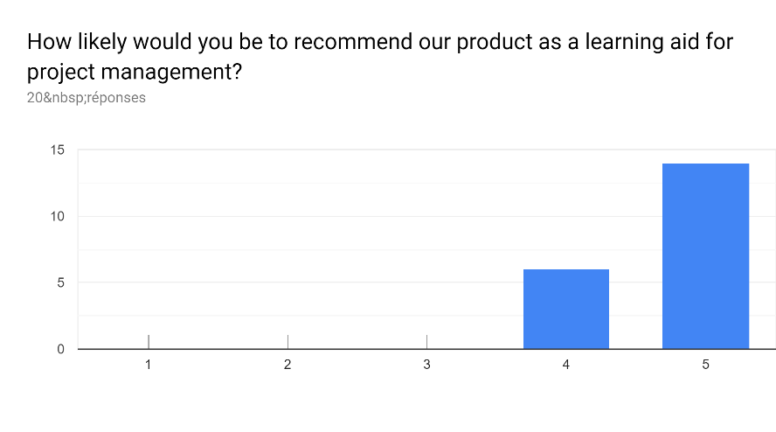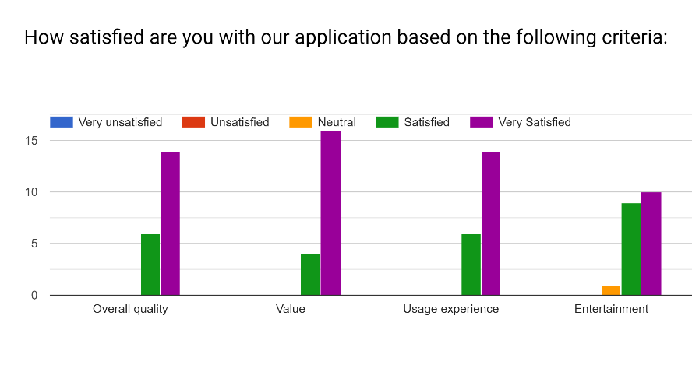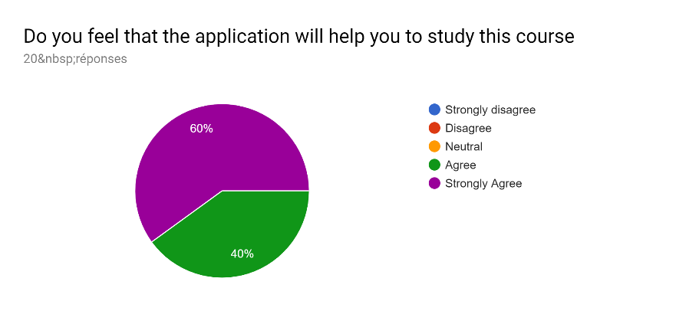 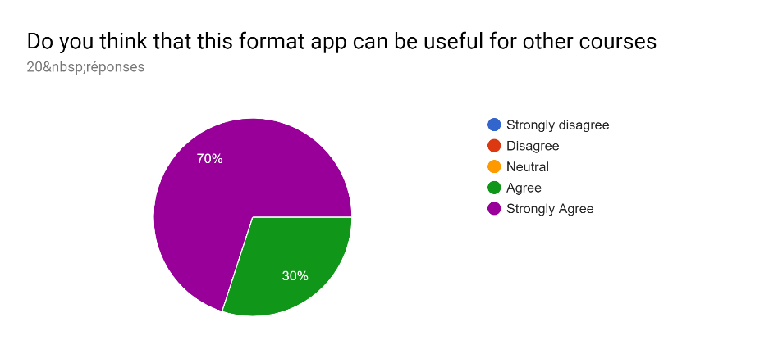

Overall, we can see our app is appreciated by the informants. From the first question we can conclude that this app is a good learning aid for project management, all the participant agreed to this statement and most of them strongly agreed. The second question gives us more details about the different aspect of the app: its weakness and strength. Although there are no unsatisfied answers to all the question, we can see that the entertainment part of the project was less appreciated by the user than the other aspect. This could have been of course easily improved with more time, by making the app a little more playful, following the idea of the monkey giving you the quiz.

The overall quality and the usage experience have been well perceived but might have been impacted by the problem we talked about earlier with the loss of progress when we change main menu.

The value created is the aspect that satisfied the most the informant: the quiz and the ability to follow your progress were well perceived.

Most people also agreed that the app will help them study this course which was one of the intended outputs of the project.

Most of them also strongly agreed that this app could be used in other courses, which is a good sign for other business opportunities, this app could be implemented for a lot a course and help student study in subject as Science, English, History...

1. Please evaluate the degree of your support to the following statement (group-based evaluation):

|  |  |  |  |  |  |
| --- | --- | --- | --- | --- | --- |
|  | Our product is of high quality and we recommend it to be used as learning aid in project management | | | | |
| Scale | Strongly  Disagree | Disagree | Neither agree nor disagree | Agree | Strongly Agree |
| Your response |  |  |  | X |  |

# Factors that have contributed to failure / success.

Critical success factors can be categorized in roughly three categories, namely: case-specific factors, structural factors and cultural factors (Hussein, 2018).

Case-specific factors cannot be generalized to other situations and are factors that are relevant to the specific situation under consideration. Not a lot of case-specific factors can be mentioned that contributed to the success or failure. The reason for this can be that there is not a lot of organizational complexity as well as constraints involved in this project since this is only a small project. But one case-specific factor that can contribute to the failure of the project is the language used in the mobile application. Since the project is executed in Norway and the project owners are exchange students from all over Europe, the mobile app is only available in English with the result that the app can only be used by English speaking persons. Another case-specific factor that contributed to the success of the project is the skills acquired to develop the app. If the project members were not able to obtain this skill, the project would have failed to deliver its output (the app).

Structural factors include factors such as communication, information exchange, planning, and project organization. The first deliverable, the project plan, contributed to the success of the project since adequate early planning is a critical success factor. The project plan is a document that explains the type of product, the expected benefits of the product, required skills, critical success factors, risk assessment plan, and project schedule. This document was a good starting point and provided a clear direction for every project owner. By means of this document, consensus was achieved about the type of the product that would be developed during the project. Furthermore, clarity of roles and responsibilities is a critical success factor that contributed to the success of this project. Every project owner was assigned a task and it was clear to every member who was responsible for the different tasks as well as the time available for every task. However, it should be noted that skills, experience, knowledge and competence had to be acquired in order to successfully develop the mobile application. This is because no project member ever developed such an app before. This factor could have resulted in a project failure, however, learning and skills about how to develop an app are acquired during the implementation. Timely information exchange also contributed to the project success. During the implementation several gatherings and meetings were held in order to get everybody in the same direction. Lack of end-user involvement in the beginning of the project can be seen as a critical factor that contributes to a failure of the project. However, the prototype is tested several times during the development by the project owners, who are also master students and possibly future project leaders. Furthermore, a survey is held among end-users and project presentations are held in the course applied project management to increase the understanding and acceptance of end-users. From this it became clear that the end-users were satisfied with the app and raped the benefits of this app.

The cultural factors that contribute to success or failure are shared values such as commitment, involvement, respect, trust and openness. These factors have considerable impact on knowledge sharing among project members, cooperation, motivation, creativity, and sense of ownership. Consequences of not being able to comply with these shares values can result in resistance to change, power conflicts, indifference, and eventually project failure. The environment in which this project is executed by the project owners is characterized by respect, trust and openness. This is created due to earlier collaboration between the project owners in the course of applied project management. The collaboration started with the in-class assignment of building a tower of paper. This in-class assignment contributed to development of the relationship between all project owners. In addition, all project owners contributed to the project by performing their tasks which indicates that there is involvement and commitment of all members. Furthermore, group meetings were arranged to ensure everybody was on the same level and this also contributed to the engagement of all project owners. Informality is another factor that contributed to the success because, in this way, an open environment was created where everybody could express their ideas and challenges.

The most significant factor for success is considered to be commitment of the project owners to the project, which is also considered an important critical success factor by Hussein (2018). When there is no commitment of project owners, they are not motivated to work together and to execute the different tasks with the consequence that the project would have failed to develop and deliver a mobile application to master students or future project leaders. The case specific factor of skills is mentioned in the book of Hussein (2018). This does not apply for the case specific factor of language, but this could be because this factor is case specific. The structural factors that apply to this project (commitment, end-user involvement, adequate early planning, clarity of roles and objectives, clarity of purpose and objectives) are also included important the critical success factors according to Hussein (2018). Lastly, all cultural factors of this project (collaboration, transparency, involvement, trust) are mentioned by Hussein (2018). It should be noted that the critical success factors listed by Hussein (2018) is more extensive than the factors listed above. According to our perception, the most factors that contributed to the success of our project are mentioned above.

# Most important lessons from your project

Since we executed the project ourselves and have practical experience with project management, we can give some advice to other students on how to work on similar projects. Firstly, our advice is to start early on the project. Since you need to create something it takes some time to come up with ideas and brainstorm. It is better to give this part of the project some more time then to hurry and start off badly.

Secondly, make sure that all project owners are on the same page regarding project goals and learning objectives. Since it is sometimes hard to meet with the whole group due to different schedules and other projects, it is important to have a clear understanding of the goal of the project. In that way it is possible to also work on the project alone, or in smaller groups, without working in different directions.

Thirdly, we learned that updating each other frequently about the progress of the project is really useful. By doing that all project members know where we stand and have an idea if we need to work faster or have more time.

Lastly, introduce deadlines for yourself during the project. Also set some slack at the end of the project, so you are sure you will finish in time even when things do not go your way immediately.

# References

Baccarini, D. (1999). The logical framework method for defining project success. Project management journal, 30(4), 25-32.

Chapman, S. (2000), “Considerations for project management”, in Sitts, M. (Ed.), Handbook for Digital Projects: A Management Tool for Preservation and Access, Northeast Document Conservation Center, Andover, MA

De Wit, A. (1988). Measurement of project success. *International journal of Project Management,* Vol. 6

Grout, C., Purdy, P. and Rymer, J. (2000), Creating Digital Resources for the Visual Arts: Standards and Good Practice, Oxbow Books, Oxford.

Hussein, B. (2018). The Road to Success: Narratives and Insights from Real-Life Projects, Fagbokforlaget.

Lopatin, L. (2006). Library digitization projects, issues and guidelines: A survey of the literature. *Library hi tech*, *24*(2), 273-289.

Murphy, D. C., Baker, B. N., & Fisher, D. (1974). Determinants of project success.

# Peer-review report

Each group is assigned a peer-review group. The list of the assigned groups is shown in the following table. The table shows for instance that the product produced by group 1 will be reviewed by group 11, and the product produced by group 2 shall be reviewed by group 22.

Before writing this review report, you need first to view/test the product produced by your test group. In your evaluation you should be **objective, fair and use to time to fill in the report.** The grade you assign based on your evaluation **is a guide** to the instructors when they grade the project assignment.

|  |  |
| --- | --- |
| Product produced by Group  (Test group) | Shall be Peer-reviewed by group  (Peer-review group) |
| 1 | 11 |
| 2 | 22 |
| 4 | 8 |
| 6 | 5+12 |
| 7 | 4 |
| 8 | 1 |
| 9 | 10 |
| 10 | 12 |
| 11 | 13 |
| 12 | 14 |
| 13 | 15 |
| 14 | 16 |
| 15 | 17 |
| 16 | 18 |
| 17 | 19 |
| 18 | 2 |
| 19 | 20 |
| 20 | 24 |
| 22 | 25 |
| 24 | 26 |
| 25 | 27 |
| 26 | 33 |
| 27 | 34 |
| 33 | 36 |
| 34 | 6 |
| 36 | 7 |
| 5+12 | 9 |

Your peer-review evaluation report

**What is name of the group you are assigned to evaluate: 2**

* + 1. Based on your evaluation (as a group) please indicate the strengths and weaknesses of the final product.

**Strengths**

The website produced by group 2 has several strengths. Firstly, the website is understandable and easy to use. Secondly, the ‘random question mix’ is a very good addition to the website. In this way you can not only practice the materials of the course per chapter, but also get questioned in a random sequence. This is the same as at the final test of the course, so it is a good practice. Thirdly, the ‘progress’ tab is very handy. It gives a clear overview of how far you are on practicing the materials. Lastly, there is a ‘review’ tab that gives the opportunity to review the website. It is always good to provide the possibility of giving feedback.

**Weaknesses**

A weakness of the website is maybe the lay-out. It looks like the lay-out needs some finishing touches. It could for example be more colorful or interactive to interest the user even more. This is however just a prototype, so it is not strange that the website is not perfect yet. Another weakness of the website is that it does not provide any theory. It just provides us with tests. It would be nice if it could also have a tab with ‘theory’ so you can read back into the theory when you for example got a question wrong.

* + 1. Please evaluate the degree of your support to the following statement (group-based evaluation):

|  |  |  |  |  |  |
| --- | --- | --- | --- | --- | --- |
|  | The product we reviewed is of high quality and we recommend it to be used as learning aid in project management | | | | |
| Scale | Strongly  Disagree | Disagree | Neither agree nor disagree | Agree | Strongly Agree |
| Your response |  |  |  | x |  |

* + 1. On a scale from 0 to 10. **What grade would you recommend for this product?**

Grade: 8