# An attempt to understand complexity in a government digital transformation project.

|  |  |
| --- | --- |
| **Kristin Helene J. Hafseld**  Norwegian University of Science and Technology  Valgrinda 2000, S. P. Andersens vei, 7491 Trondheim  Norway  Kristin.h.j.hafseld@ntnu.no  **Bassam Hussein**  Norwegian University of Science and Technology  Valgrinda 2000, S. P. Andersens vei, 7491 Trondheim  Norway  [bassam.hussein@ntnu.no](mailto:bassam.hussein@ntnu.no)  **Antoine Rauzy**  Norwegian University of Science and Technology  Valgrinda 2000, S. P. Andersens vei, 7491 Trondheim  Norway  antoine.rauzy@ntnu.no |  |

**Abstract:**

Digital transformation projects will be one of the dominating tools for mastering digital transformation in governments. Research studies show that these projects are complex undertakings and increasingly difficult to manage. The purpose of this paper is to provide a better understanding of the factors that causes complexity in government digital transformation projects. By employing an in-depth case study approach, we investigate factors of complexity in an ongoing digital transformation project. The results indicate that complexity in digital transformation projects are rooted in dynamic relationships between multiple dimensions of organization, technologies, and innovation. When organizational structuring, introduction of new technology, and efforts to innovate and create added value for citizens and businesses operate in tandem, the pervasive complexity associated with delivering government digital transformation projects becomes increasingly difficult to manage.

**Keywords:**

keyword 1; digital transformation projects 2; government 3; project complexity 4; digital technology 5; inter-organizational cooperation

1. Introduction

Project complexity has received much attention from practitioners and academics alike during recent decades [1], and significant progress has been made in understanding the different aspects of complexity in projects [2]. Although extant studies provide useful insights on project complexity in a number of industries such as engineering and IT/IS [3, 4], we still know very little about complexity factors in government digital transformation projects, and what may causes complexity in these projects. Drawing upon the emerging field of project complexity management literature and an in-depth case study approach, we attempt to explore the nature of complexity in a government digital transformation project.

Digital transformation projects typically involve aspects of information technology (IT), innovation, and organizational change, thus requiring the integration of multiple perspectives [5] [6]. Placed in a government context, these projects require particular treatment due to the extensive size and scope that most projects have, in terms of time, context and users’ audience [7]. Further, they are often referred to as complex, involving a multitude of stakeholders, novelty, bureaucratic organization structures, and political constraints [7] [8]. Despite strong ambitions regarding the potential of government digital transformation, research studies report high project failure rates, cost and time overruns, in addition to unmet functional specifications [7, 9-11]. Lack of understanding of the complexity of digital transformation and the relationships among technologies, information use, organizational contexts, and institutional arrangements are reported as factors explaining the failures in transforming government organizations [12].

In order to enable digital transformation, capabilities of digital technologies should be coupled by other factors such as culture, strategy, and human capital [13]. Kohnke [14] found that organizations are investing in digitalization without trying to push the necessary changes because they underestimate the organizational implications and the people dynamic of the digitalization process which includes the need of aligning people, processes, organizational structures and culture. This indicates a lack of awareness of the interconnections between these important features of digital transformation, and the necessity to consider them in alignment rather than individually. Considering the use of different digital technologies and various forms of value creation, structural changes are often needed to provide an adequate basis for the new operations[15]. This further indicates that there is an alliance between the dimensions of technology, innovation and management.

The purpose of this paper is to provide a better understanding of complexity in a government digital transformation project. In order to investigate the complexities in such projects, we framed our research by applying the following research postulate:

*Complexity in government digital transformation projects is rooted in the interplay between the factors of organizational structuring, technologies, and efforts to innovate. With these factors operating in tandem, the pervasive complexity associated with delivering digital transformation projects become increasingly difficult to manage.*

The research was performed in Norway in 2019/2020. The methodology is qualitative, in-depth case study, based primarily on interviews, however supplemented with observations and document studies. The selected case is an ongoing digital transformation project that includes collaboration between several government agencies and sectors with the aim to produce seamless, digital services for citizens and businesses. We used a thematic analysis approach, and a qualitative data analysis software tool was applied to organize the data.

The results suggest that organizational complexities, i.e. collaboration challenges, technical complexities, i.e. lack of knowledge and familiarity with advance and new technologies, and complexities related to introducing innovative, digital solutions to citizens and business, all relate to one another. Their interrelationships may create additional challenges and complexities which must be dealt with by the project managers. In other words, digital transformation projects in governments may become increasingly difficult to manage when factors related to organizational structuring, selection and implementation of purposefully technological enablers, and bringing innovative, digital solutions to citizens and businesses, all operate in tandem.

This paper offer one approach to understanding the complexity of digital transformation projects in governments. We explored the relationships and the interconnections between core dimensions of digital transformation projects. Thus, the paper may add to the evolution of project complexities theories and practice, by presenting indications on how the elements of complexities may be intertwined in a digital transformation project. By investigating the root causes, we hope to raise awareness of the difficulties of embracing and managing complexities in a government digital transformation project.

In the following, we first introduce the theoretical background with reference to related work on digital transformation projects, and on project complexity. Thereafter, we outline a conceptual framework (Venn diagram) for investigating the interplay between variables related to organization, technologies, and innovation. Then we describe the case and our research design and methods, including an explanation of how the case study was conducted and the data analysis was undertaken. The main findings are presented and discussed, including in relation to relevant literature. The paper is concluded with an explanation of the main research results, a description of the limitations of our research, and proposed themes for further research.

1. Related work
   1. The core dimensions of digital transformation projects

In investigating complexity in government digital transformation projects we choose to focus on factors related to the dimensions of organizational structuring, technologies, and innovation, as these are referred to by several authors as being the core of digital transformation projects [5, 6, 11, 16-18]. The three mentioned dimensions have been reported as the most important elements challening the management of of digital transformation projects[18].

*Organizational* *structuring* in digital transformation projects include factors such as project planning and management, coordination of the project team and the tasks, stakeholder management, governance, and organizational power and politics [8, 17]. Each of them influencing the project execution and management process. In other words, the organizational dimension concerns the “how” and the “who” of the project in terms of *how* the project is organized and executed, and *who* is involved, which includes the owners, project group members, and stakeholders.

A typical feature of government digital projects is the increased use of inter-organizational and cross-sector collaboration, in addition to co-creation of value and cross-jurisdictional networks [19-21]. Inter-organizational collaborations are motivated partly by new opportunities afforded by digital technologies [22] and partly by organizational redesign sparked by processes related to new public management (NPM) and public value management (PVM) [23, 24]. The resulting organizational configurations imply that digital transformation projects have to deal with increasing numbers of stakeholders and increased complexity. This situation presents specific challenges for a project’s delivery of consistent public value with respect to efficiency, transparency, and accountability[25].

*Technology* is a fundamental component of any digital transformation project, thus it is important to understand the current state of technology being used in the project [8, 12, 16, 17]. In digital transformation projects technologies are typically defined as combinations of *social*, *mobile*, *analytics*, *cloud*, and the *Internet of Things* (IoT), often referred to as the SMACIT technologies. The use of SMACIT technologies is actually what distinguishes digital transformation from previous IT-enabled transformations. The adoption of these technologies is a new venture for many governments, as the scale and scope of the changes associated with their use are unclear [26]. Platforms are also cited as an important category of technology used in government digital transformation efforts [17].

*Innovation, or digital innovation,* is regarded as constituting one of the core elements of digital transformation [5], [27]. The use of digital technology during the process of innovating is referred to as digital innovation [28]. Digital innovation concerns, among other things, radical change of the nature and structure of new products and services, resulting in novel value creation. Since digital transformation in most cases is realized through projects, the characteristics of digital innovations will impact management of digital transformation projects [5]. Accordingly, this dimension is considered important to investigate. Authors have reported that the intersection between digital transformation and innovation is multi-faceted and multi-dimensional, and challenging to manage [17, 27].

* 1. Project complexity

The rapid technological advancements and fast changing organizational environments have contributed to projects becoming increasingly complex [29]. Defining project complexity however, is not easy due to it’s vague nature, and to date no coherent definition of project complexity exists [3, 30]. Despite difficulties of defining complexity, several researchers underline that a high level definition of project complexity should include aspects of structural, and dynamic interactions of elements [29]. According to Baccarini, project complexity is “consisting of many varied interrelated parts and can be operationalized in terms of differentiation and interdependency.”[31]. This definition has been further developed by both Baccarini and other researchers, proposing to first include organizational complexity and then technological complexity [32]. Geraldi [33] expanded the complexity concept by including the softer aspects taking place at the intersection between people and technology, such politics, ambiguity and empathy. Another element that is considered as a dimension of project complexity is uncertainty, i.e. uncertainties in goals and methods [32].

According to Browing [34], a complex project comprises of multiple and multidimensional activities that are interrelated to one another in various ways to accomplish a shared goal or objective [34]. Following this, Oehmen et al.[35] identified four characteristics of project complexity: (1) it contains multiple components; (2) it processes a number of connections between the components; (3) the interactions between components are dynamic, and finally; (4) the behaviour of the project resulting from the interplay among the components cannot be explained as the simple sum of the components. The four characteristics imply that the interplay between the components is far more complex than just adding the parts; rather they are interconnected in dynamic and extensive relationships that impact the behaviour of the project. Therefore, conceptual and integrative project complexity models should take on a holistic approach and be able to capture the important types of variables, and assist in describing and understand their relationships [8, 29].

Project complexity literature differentiates between *structural* and *dynamic* complexity [3, 32] [36]. Structural complexity refers to the number and types of elements and their relationships in a project, whereas dynamic complexity refers to the “behaviour” of the project. *Structural* complexity, also known as descriptive complexity, is defined as consisting of several interrelated or interacting elements, in which interdependence is a strong characteristic [31]. It also refers to organizational and technical complexity [32]. The organizational complexity consists of the structure of the project organization, including the project’s stakeholders and their relationships, as well as the project processes. According to Marle and Vidal, ca. 70% of project complexity factors are linked to organizational aspects [2].

The technical complexities concerns both the technical structures of the main deliverables [35], but also “softer” aspects such as knowledge and familiarity with advance technologies [31]; in addition to technology-based project innovation [2, 33, 37], and expertise and skills needed to handle technical risks and requirements [29]. The organizational and the technical complexity are closely related to one another [35].

The *dynamic* complexity includes aspects that impact and “moves” the behaviour of project, such as uncertainty, ambiguity, and variability [36, 38]. In other words, dynamic complexity is not a “static” snapshot of a particular point in time, but rather evolving complexities. Consequently, control of the individual elements is not a guarantee of control over of the whole project or of the overall behavior of the project [39]. A typical feature of dynamic complexity is uncertainty in both goals and methods [32, 38, 40]. Dynamic complexity may also arise from ambiguity or uncertainty related to the tasks or the system [41]. Another aspect of dynamic complexity is it’s alignment with factors such as interdependence, unpredictability, and adaptiveness [42, 43].

1. Building blocks for understanding complexity in digital transformation projects
   1. The interrelated dimensions of digital transformation projects

In an attempt to understand complexity in a digital transformation projects, we choose to operationalize, and map, the three core dimensions of the digital transformation project (organization, technology, and innovation) in a Venn diagram (Fig. 1). Through the use of a Venn diagram, we initially suggest that none of the three dimensions is prima facie more significant relative to the others. Further, we suggest that each of the dimension, in isolation, have some challenges that the project has to deal with. However, as these three dimensions do operate within a system (a project) there are interconnections and relations between them [13, 44]. Our primary assumption is that additional challenges and creation of complexities in a digital transformation project is rooted in the dynamic relations that are at play between the dimensions of organization, technologies, and innovation. The interplay between the variables will add up to the known challenges found in each singular dimension. By use of the case study and the qualitative data generated from the case we will explore the relationships between the three dimensions.

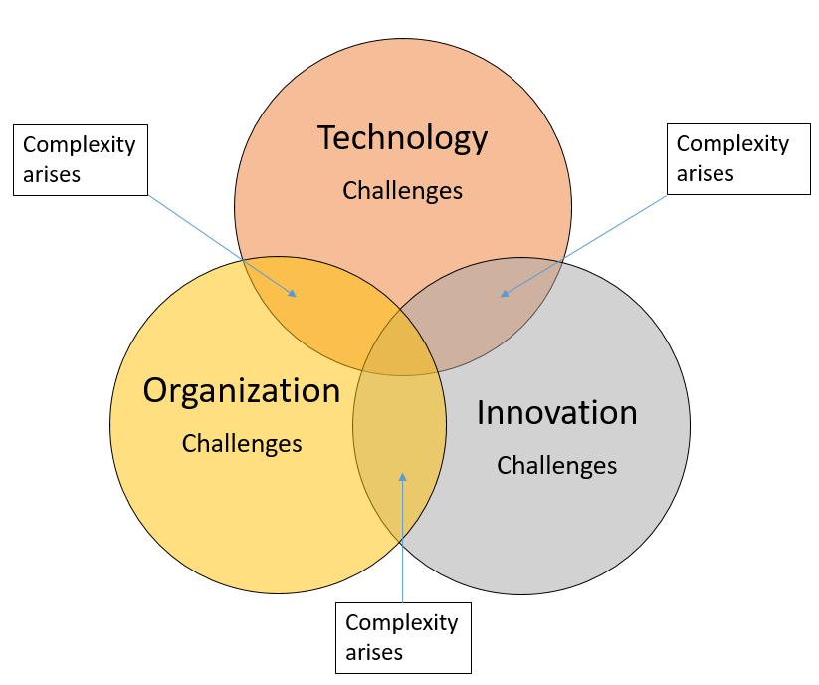

Fig. 1. The dimensions of government digital transformation projects

1. The case

In 2016, the Norwegian Public Roads Administration (NRA), together with three different government agencies, decided to collaborate in a digital transformation project with the aim of streamlining the ineffective, bureaucratic practice of renewing the driver’s license for the professional heavy truck drivers and the drivers of 80 years and above. In Norway, as in several other European countries, it is mandatory to carry a valid health certificate for the professional drivers of heavy trucks, buses and minibuses, and for the drivers above 80 years of age, when renewing their drivers’ license. The process of obtaining the health certificate, which needs to be renewed regularly, is time-consuming for both the professional drivers and the drivers of 80 years and above as they have to show up at the doctors, doing a health examination and then bring the health certificate in paper to the NRA-offices for renewing of the drivers’ license. Behind the “scene”, the handling of the driver’s license renewal process is ineffective and “tangled”, involving coordination of several inter-related tasks between multiple public agencies.

The project’s objective was to streamline and digitalize the analog processes, including the submission of health certificate from the General Practitioners (GPs) to the NRA, saving time and money for the groups of drivers involved as well as for the GPs filling out the health certificates and for the NRA that handle the issuing of the licenses. By developing a digital health certificate, and enabling a digital transmission of the health certificate from the GPs to the NRA, the project would make the physically show-up of the drivers at the road administration offices superfluous. Another outcome of the project is development of an app for the drivers informing them about the completion of renewal of the license. The drivers can then choose to carry a fully digital driver’s license or a physical one. The digitalization of the renewal process would also result in more effective operations at the NRA, reducing the working hours spend on the process and the number of staff involved. In addition, the doctors would be more effective as the filling-in of the health certificate will be less time-consuming.

In order to provide the seamless, digital services for the citizens and businesses and streamline the ineffective, bureaucratic handling of the process, the NRA needed to collaborate with the health care sector and the police authority, both sectors having important stakes in the management of the driver’s license renewal process, ref. Fig. 2. The health care sector includes the Directorate for Health and Directorate for e-Health. The first one is responsible for the medical supervision of the health certificate that the doctors need to fill out, whereas the latter one is the responsible body for the digital transformation of the health care sector in Norway and the one with the digital expertise in the field. The Police Directorate, the driver license’ enforcement body, has traditionally handled administrative tasks in relation to breaches of the Road Traffic Act in cases where the drivers’ did not have their health certificates updated or in cases of breaching the traffic act. The incentives for The Police Directorate to be a part of the project was to transfer their present administrative tasks and their authorities to the Norwegian Roads’ Administration, reducing the number of public agencies involved and contribute to streamlining the process of license’ renewal.

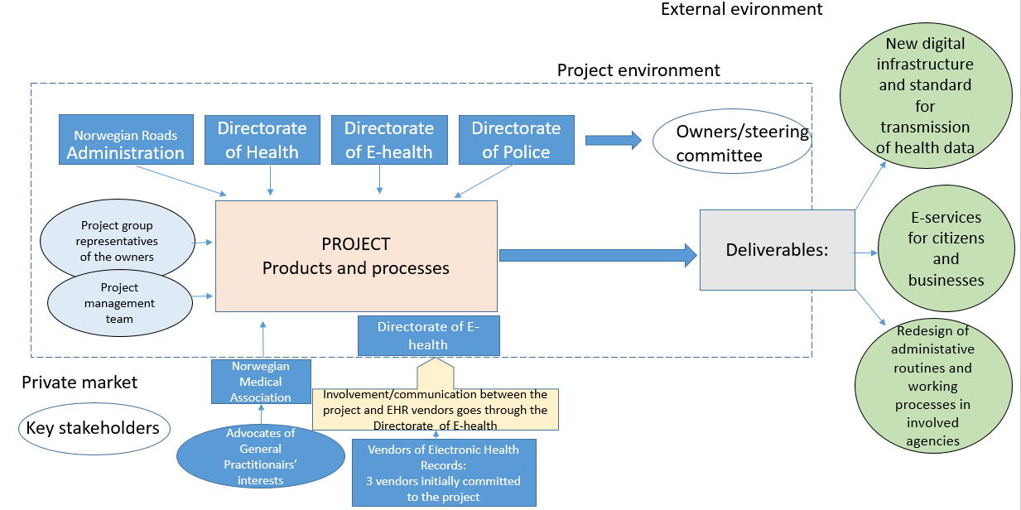

Fig. 2. Overview of the case and the involved stakeholders

*4.2. The choice of the digital technology*

The project decided to adopt and implement the US-developed framework “Smart on FHIR” (SMART App Launch Framework) to facilitate the digital transmission of health data. The final choice of technology came late in the project life cycle, and was a result of recommendations from the Directorate of E-health, the member agency responsible for the digital development of the health care sector. The chosen digital framework will enable going from analogue systems of messages and receipts to sharing of real time health data among health care institutions and between public agencies. The project would be the first one to adopt the new technology in the Norwegian market. The project claims that the chosen digital framework is a “game changer” that may create substantial value for society if adopted by several health care organizations. Some of the project member agencies envisioned this choice of technology as a step forward on the digital transformation journey of the health care sector, while others wary about the choice leading to an expansion of project scope. However, all member agencies supported the final decision.

A summary of the case related to aspects of organization, technology, innovation, and value creation is presented in Table 1.

Table 1. Overview of the case in relation to organization, technology, innovation, and value creation

|  |  |  |
| --- | --- | --- |
| **Organizational structures** | **Technology (digital enabler)** | **Innovation** |
| Four owners representing three sectors: roads, health, and police  Three major stakeholder groups:  GPs, suppliers of electronic health records, and citizens/businesses | The framework Smart on FHIR (SMART App Launch Framework) facilitates the digital submission of health data.  Implementing the SMART framework will enable both implementation of, and updates to, electronic health records.  New technology functionality in the electronic health record (through the use of FHIR) facilitates implementation of a digital health certificate. | Transformation from analogue systems for messages and receipts to sharing of real-time health data  Developing a new application for use by citizens and representatives of businesses for use when renewing their driver’s licenses  Developing electronic health certificates by implementing new standards in the health care sector |

1. Research design and method

This research aims to understand complexity in a government digital transformation project. We used a case study as the research method for collecting the data. According to Benbasat et al [45] there are three key reasons why case study research is an appropriate research strategy in fields where information system and (digital) technology are involved. First, the researcher can study information systems and technology in their natural settings. Secondly, the case study method allows the researcher to answer "how" and "why" questions, that is, to understand the nature and complexity of the processes taking place [46]. Lastly, the case approach is an appropriate way to research an area in which seeks new insight due lack of previous studies. In this respect, an in-depth case study was considered an appropriate research method for collecting the necessary data and analyzing complexity in digital transformation projects. The single case study design is also commonly used in digital government research [12, 47] [12] [47].

The selection of the case was taken on the basis of high expectations about the information content it will provide. A typical or extreme case often reveals more information because it involves several actors and basic mechanisms in the situation studied [48]. For our study, we sought an ongoing digital transformation project that was set up to produce high-end, seamless digital solutions for citizens and businesses. A second criterion was that the case should include collaboration between several public agencies and sectors. Studies have shown that digital transformation projects in the public sector tend to be more concerned with collaborative, inter-organizational strategies and value creation compared with traditional IT-projects [49, 50]. A third and final criterion when selecting the case was to investigate a case that had been running for some time, thus having the potential to provide information on project experiences.

* 1. Data collection

Data were collected through a combination of semi-structured, in-depth interviews, observation and documentary searches. The interviews and the observations constitute the primary data, while project reports, minutes from meetings, project evaluations, as well as government’s report such as national digital transformation strategies, constitute the secondary data (Table 2). The interviews sampled a size of total 10 participants representing the four organizations collaborating in the project. The participants interviewed were members of the project group, the leader, and a member of the steering group, in addition to two project managers (Table 2).

Each interview was conducted face-to-face and lasted ca. 1 hour. During the interviews, the interviewees were asked to elaborate on the challenges and difficulties experienced in the project, with a focus on aspects of project organizing, technologies, and innovation. An interview guide informing about the format and focus of the research study and the interview process was sent to the participants in advance of the interviews. The first author conducted the interviews between November and December 2019. The interviews were recorded and then transcribed verbatim (a total of 42,500 words).

The data were triangulated by applying multiple data collection techniques, including multiple interviews, observations and review of documents[51] [51] (Table 2). Observations at meetings, document studies, reviewing project reports, mandates, and evaluation reports were undertaken to validate and provide context to the respondents’ views, thus enabling empirical triangulation. To increase reliability and enhance transparency a case study protocol was constructed along with a case study database. The database, established in the software program NVivo, included case study notes, documents, and analysis.

Table 2. Overview of the collected data.

|  |  |  |  |  |
| --- | --- | --- | --- | --- |
| **Data sources** | **Number, or time used** | **Description** | **When** | **Type** |
|  |  | **Primary data** |  |  |
| Interviews | 10 | Semi-structured, in-depth interviews with two project managers, the leader of the steering group, a member of the steering group, and six project group members | November- December 2019 | Face-to-face interviews |
| Observations | 7 hrs | Observations made in two meetings: 1) of project members participating in project group meeting (4 hrs), and 2) of steering group members participating in steering group meeting (3 hrs). | September-October 2019 | Observant at meetings |
|  |  | **Secondary data** |  |  |
| Reports such as project mandate, project description, minutes from meetings, evaluations | 10 | Background information, evaluations of front-end phase, communication plans, budget and planning reports, risk-evaluation matrix, meeting agendas and decision points, financing and operations | May 2019-April 2020 | Written documents |
| Government’s reports and strategies on digital transformation | 6 | Government agencies’ reports  on digital transformation initiatives; evaluations of projects  and implemented initiatives,  Government’s national digital strategies | May 2019-April 2020 | On-line, and written |

* 1. Data analysis

### In this research study, we use a grounded theory-approach [52]. It is a systematic methodology that can assist in the development of explanatory models grounded in relevant empirical data[52]. Interviews are considered a common form of collecting data in research where this method is applied [53, 54]. The data were analyzed by use of a thematic analysis approach [52, 55]. This method provides ways to identify patters in large data set. Further, it offers means to effectively and accurately identifying relations and links within analytic themes.

### Following this, a four-step process was applied [55, 56]:

* in-depth analysis of the raw data, including coding and identifying first-order categories (nodes) of codes;
* examine the first-order categories further to identify links, patterns and relationships among them;
* forming aggregated dimensions of project management challenges and project complexities, including using insights from literature
* comparing and analyzing the aggregated dimensions, which allows for identifying relationships and linkages across the dimensions

NVivo software was utilized for organizing and analyzing the data from the interviews. The software is especially suitable for this research as makes it possible to conduct content analysis of rich qualitative data. It is a process of "contextualizing and making connections between themes to build a coherent argument supported by data"[57]. Bottom-up coding, also referred to as “data-driven themes”, was used to identify and create labels of themes and patterns that were strongly linked to the data [58].

The first step involved reading the interviews, located in NVivo, several times, coding common words, phrases, terms, and labels mentioned by respondents. Then the first-order categories of codes were identified, reflecting the views of the respondents in their own words. In the second step, related text located at different nodes were located together based on repeated, common phrases or ideas. The repeated ideas were grouped together into themes by the process of selection, forming coherent categories. As the themes started to develop, the more hierarchal orders of nodes were made, building broader themes related to project challenges. In NVivo the term “node” refers to any named concept that represent what is defined in the data as meaningful in relation to the research project’s objectives. To organise these, NVivo allows nodes to have more than one dimension (tree branch), thus enabling us to group them together to build a more general concept. NVivo labels this process as building tree branches. Sorting concepts into branches in trees assisted us in identifying common properties and make early comparisons. In order to ensure proper validity concerns [59], insights from secondary resources, such as reports and evaluations, were taken into consideration. Fig. 3. is an example that illustrates how the first step of the data analysis was performed.

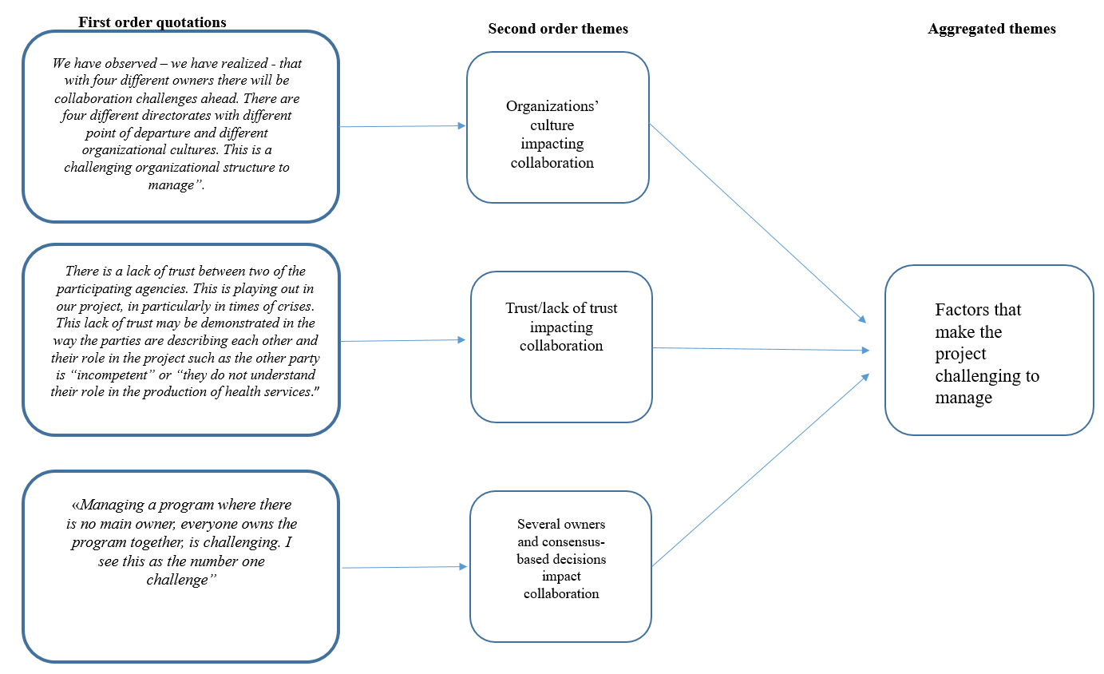

Fig.3. Examples of first and second steps of coding, building hierarchy of nodes and aggregated themes

The third step generated aggregated dimensions, which represented a higher level of abstraction. In this phase, the second-order of themes are combined with insights from literature on project management on challenges related to management of digital transformation projects. An example of the data structure generated from the data analysis in third step is presented in Fig. 4.

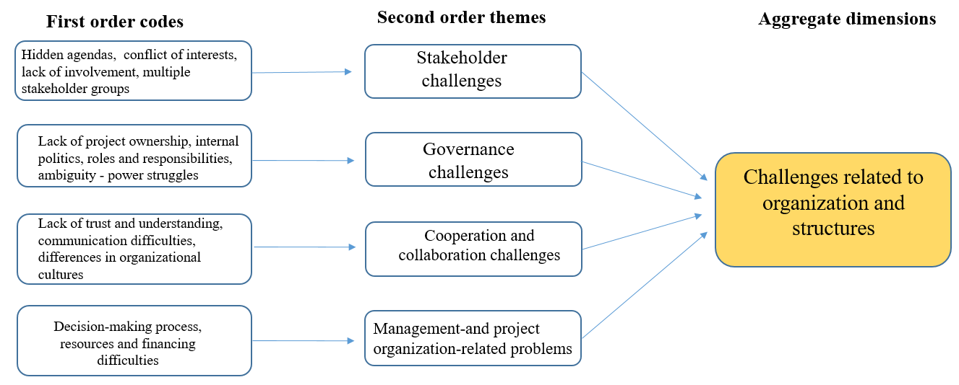

Fig. 4. Examples of Step 3 in the data analysis process: Creating data structure related to the organizational dimension.

The fourth and final step included the practice of comparing and analyzing the aggregated dimensions, which allows for identifying relationships and linkages across them. The matrix coding query function in NVivo is suitable as a search tool for investigating relationships between themes and concepts [60]. The query examines any possible appearance of themes that are closely associated with each other. The results are presented in tables in which each cell in the matrix display a chosen information concerning the corresponding pair of items. In this research the cells contain the numbers that represent corresponding coding references (Table 2.). Consequently, from these results we were able to examine a number of themes which appeared to be closely interconnected. A further investigation of these interrelationships may tell us something about the emergent of dynamic and extensive relationships between elements that may cause complexity and impact the behaviour of the project.

Table 2. Example of running a matrix query creating tables with cells. The scale colors denote whether the correlation is high (red) or low (green)

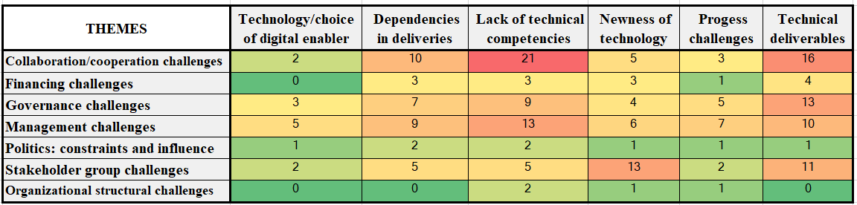

1. Results and discussions

This section presents and discusses the elements of complexities we have discerned in this particular case. Based on the methodology described above, which included a triangulation of the literature, documents and interviews, we were able to distinguish elements of complexities within the dimensions of organization, technology, and innovation. While they have been put forward in the project complexity literature separately to greater or lesser extent, the results from our data analysis, which included running matrix queries, indicate that complexity in this government digital transformation project incorporate multiple factors and is a result of a dynamic and extensive interplay between complexity elements from all three dimensions.

The section is divided in two main parts. First, a presentation of the complexity elements in each of the dimensions, followed by a description of the relationships that are at play between complexity elements of the three dimensions. The first part includes Tables 3, 4, and 5, which comprise the complexity elements prevalent in each of the dimensions of organization, technology, and innovation. Each complexity element is further described based on an analysis of the respondents own wordings, which then have been aggregated into more over-arching themes using the software NVivo (ref. 5.2.).

The second part describes and discusses the complexity that emerge from the interplay between the dimensions. By running matrix queries in NVivo, we explore the relationships between the identified elements of complexity, assuming that additional complexities emerge where these dimensions interplay. The interplay between the variables of the dimensions will add up to the known challenges found in each singular dimension.

* 1. Complexities related to the organizational dimension

The results from the data analysis indicates that most of the complexity elements in the project case are to be find in the organizational dimension. The group of challenges identified include governance challenges, i.e. lack of project ownership within the participating organizations, cooperation and collaboration challenges, including lack of trust and understanding between the parties involved, management-related problems, resources and financing, stakeholder management, communication difficulties, and issues related to politics. An overview of the groups of challenges contributing to complexities in the organization dimension are presented in the table below (Table 3).

Table 3. Groups of challenges contributing to complexities in the organization dimension

|  |  |
| --- | --- |
| **Elements contributing the most to complexities in the organization dimension:** | **Description:** |
| Collaboration and cooperation challenges | Inter-organizational collaboration, lack of trust, hidden agendas, lack of transparancy, differeneces in the organisations' culture, communication challenges |
| Stakeholder management | Number and varity of stakeholder groups, multiple owners, lack of involvement, critical interest group (suppliers); dependencies |
| Governance challenges | Lack of steering, and anchoring within the participating organizations |
| Management challenges | Project organizing, including frequency of meetings, documentation, ineffective meetings, ineffective decision-making processes, lack of, and diversity in resources, lack of project maturity |
| Financing | Uncertainties about funding, several funding sources and differences in financing mechanisms between the owners; insecure future funding; "who pays for what"? |
| Politics: constraints and impact | Bureaucratic structures; silos; focus on taking care of interests of own sector/organization, political issues and public administration policies |
| Structural challenges within the sectors and the organizations | Differences in organizational structures, differences in the sectors' structure, re-organizations within the owners' organization |

* 1. Complexities related to the technology dimension

The challenges related to the technology dimension include the choice of technology, which was not known in advance of the project’s establishment, thus creating a high degree of uncertainty. The project also faced challenges due to lack of technical competencies in the project group, which made the communication among the project members difficult. Late involvement of key stakeholders groups has contributed to frequent adaptation of new requirements and changes in the digital solution, and hence expanded the scope of the services that were intended to be introduced by the project. An overview of the groups of challenges contributing to complexities in the technology dimension are presented in the table below (Table 4).

Table 4. Groups of challenges contributing to complexities in the technology dimension

|  |  |
| --- | --- |
| **Elements contributing the most to complexities in the technology dimensions:** | **Description:** |
| Lack of skills and competencies | Lack of technical and digital competencies, and experiences with technology |
| Choice of technology/digital enabler | Difficult discussion in the project; technology not known in advance |
| Technical deliverables | The “hard” deliverables, the platforms; interoperability challenges |
| Newness of technology | Challenges of introducing new technology to the health care market |
| Dependencies in deliverables | Multiple depenedencies in technical deliveries |
| Requirements – specifications | Changes in the requirements |
| Progress challenges | The late choice of technology, the change in requirements, depenedencies in delivery, impact progress |

* 1. Complexities related to the innovation dimension

In the innovation dimension, the main challenges relate to change, uncertainties, and expansion of scope. The chosen technology is a “game-changer” in the way that it processes and transmits health data, and thus there is a huge innovation potential associated with it. As the technology is new to the Norwegian health care market, the project had to invest a lot of resources to create awarness and acceptance of the digital solutions among key stakeholders, i.e. the suppliers of electronic health records, and the user groups such as the doctors, in additions to the politicians, and public health care officials. These tasks and aspects, which was not planned for, influenced the scope of the project. Further, the findings show that there are challenges related to value creation and benefits realization as the involved agencies are uncertain about where and when the benefits will be realized and added value created. An overview of the groups of challenges contributing to complexities in the innovation dimension are presented in the table below (Table 5).

Table 5. Groups of challenges contributing to complexities in the innovation dimension

|  |  |
| --- | --- |
| **Elements contributing the most to complexities in the innovation dimensions:** | **Description:** |
| Uncertaities | Uncertainty related to technology, market adoption, competencies |
| Change | Introducing change, i.e. in work processes, and new opportunities as a result from the innovative, digital services |
| Expansion of scope | Expansion of project scope; need more time, development; research; involvment of political administration |
| Value creation | Value creation and benefit realization challenges in terms of whom will gain, and where the benefit realization will take place |

* 1. Summing up: the elements of complexty related to organization, technology, and innovation

A summary of the above results indicate that the project has experienced complexity related to organization, technology, and innovation. The identified groups of complexity elements resonate with the results and the conclusions derived from several other research studies identifying and categorizing complexity factors into organizational, technological, and innovation related groups [29, 36, 61], among others. The identified groups of complexity elements separately constitute management challenges for the project. Project management literature and research studies have responded to these types of challenges by presenting a multitude of strategies and management tools for how to embrace, tackle, and manage complexities related to organization, technology, and innovation [4, 29, 62].

The trend in the project complexity literature is a stronger focus on projects being unique and should be treated as such, explicitly taking into account the contextual and environmental influences [63, 64]. Accordingly, we assume that this particular project case has some contextual aspects that make it unique, for instance the public context in which it operates. Research studies also report that projects which are set up to deliver digital and IS solutions, no longer can be regarded as a purely technologically focused endeavours, since the complexity embedded in these projects has multiple implications [4]. In line with this, we assume that complexity in this government digital transformation project incorporate multiple factors and is a result of a dynamic and extensive interplay between complexity elements from all three dimensions.

* 1. Investigating the interplay between the organization, the technology, and the innovation dimensions

Recalling that, with organizational complexity, digital technology, and innovation, the level of uncertainty and complexity increases [27, 65], we investigate the intersections in which the dimensions of organization, technology and innovation meet. We elaborate in particularly on the results emerging from the following intersections:

* Complex situations that arise on the intersection between managing organizational issues and the efforts made for the selection and implementation of new technology.
* Complex situations that arise on the intersection between managing organizational structure and attempts to acquire and introduce innovative digital solutions that create value for the users and end-users.
* Complex situations that arise on the intersection between efforts to introduce innovate digital solutions, and efforts to select and implement purposeful digital enablers. This intersection defines the space of possibilities.

The results indicate that complex situations arise on *the intersection between managing organizational issues and the efforts made for the selection and implementation of new technology*. High correlations generated from running a matrix query indicate that the challenges of cooperation and collaboration (organizational complexity) in the project are closely related to lack of technical competencies within the project group (technical complexity). The members in the project group hold different professions such as doctors, engineers, lawyers, and IT experts. The variety of professions in the project group make the communication among the members demanding, in particularly during the process of selecting the digital enabler. The lawyers and the doctors, who represented the bureaucratic side of the project group (the Police Directorate and the Directorate of Health) did not have the same technical competencies nor the digital skills as the IT experts from the Directorate of E-health and the NRA. This made communication and discussions about the technology complicated, as stated by one project member (lawyer): “When the “digital side” of the project, i.e. those with the technical expertise, tried to explain the challenges of the digital solution to those of us lacking digital competencies, we talked past each other. The bureaucrats that lack the technical competencies could not make themselves understood, nor could they understand what the IT experts explained, as they were not speaking the “technical language.” The consequences being that those with little technical competencies needed “three rounds of explanations” from the IT experts prior to understanding the technology and the challenges associated with the technical solution. Gaps between the parties in digital competencies and experiences with technology impacted the project performance in terms of time overrun, as described by the project manager:“We have had long and difficult discussions about technology, as several members of the project group do not understand the technology, they lack competencies, and how a digital development project is undertaken. This has been demanding, impacted the progress, and somehow exhausted the project and its members.”

The results indicate that the interplay between the organization dimension and technology dimension is a meeting between technocrats and bureaucrats. The two parties represent different cultures and communicate using different jargons, the technocrats use the ICT-jargon of the digital world and the bureaucrats speak the civil service jargon of the bureaucratic universe. The findings indicate that misunderstandings, communication difficulties, and differences in organizational culture, are elements contribute to complexity in the intersection between organization and technology.

A government inter-organizational project that is set up to deliver seamless, digital services for citizens typically involve parties representing the different government agencies, that all have a stake in the development and implementation of the digital service [49]. Several authors have identified and reported organizational challenges in inter-organizational collaboration projects, such as lack of resources, development of adequate organizational capabilities, and cultural challenges [49, 66, 67]. As demonstrated in this case, these types of organizational challenges interplay with the challenges of developing, introducing, and implementing new, digital technologies. Hence, the project has to deal with both the challenges of collaborating in an inter-organizational project (organizational complexity), and the challenges related to selecting, and introducing new technology to the market. A recent study on complexity factors in the ICT industry [64] revealed that “interfaces between different disciplines*”* is an element of complexity in ICT-projects. The complexity related to challenges with collaboration between parties representing several sectors may be understood as these projects involve close collaboration between sectors that might not have a history of cooperation, in addition, the project has to rely on these interfaces for obtaining a broader, public goal. Research studies of project complexity in IS projects also show that technical aspects such as lack of knowledge and familiarity with advance and new technologies and lack of skills and competencies in handling technical risks and quality requirements, impact the organizational processes and managing of the project [29-31]. The study on complexity in IS projects also reiterated that selecting the right competencies are highly critical in coping with technological complexity, and should be considered an important task of the project manager [4]. In government digital transformation projects, [21, 66], selecting and devoting the right resources to the project might highlight a more critical problem that occurs in current project practice in the public sector. That is dealing with constrained resources [29, 66] which impact the selection of people and competencies put on a project.

Investigating the relationships between the challenges that arise in *the intersection between managing organizational structure and attempts to acquire and introduce innovative digital solutions,* the results suggest that management of the stakeholder relations (a complexity element identified in the organization dimension) is closely connected to the uncertainties of introducing digital innovation to the market. There are uncertainties related to the stakeholders’ acceptance of the digital innovation, for example if the general practitioners will make use of the digital services delivered by the project, and accept the changes in the work procedures. The acceptance of the digital solution introduced by the project is a “make or break” for the project, according to the project manager: “The technology choice and the importance, or challenge, of getting the suppliers of the EHR (electronic health record) and the general practitioners on board, convincing them that this solution will benefit them, on a larger scale, is the major challenge of the project. If the doctors do not use the system then the project will fail.” As the findings indicate, the project is highly depened on the external stakeholders in creating added value for the end-users. Hence, meeting these stakeholder groups’ expecations are key for succeeding. However, additional challenges emerge as the project has to balance the stakeholders’ need and expectation with the challenges of introducing innovative, digital solutions to the market.

The uncertainties associated with the implementation of the new, innovative technology are concerns brought forward by the project members: “The project has to take on the responsibility of pushing this digital solution into the market, which has expanded the scope of the project. The project had to investigate possible new opportunities by investing in research, [and] documenting the impact and positive effects of the chosen technology.” These efforts in supporting the introduction of the new technology may have had negative consequences for the involvement of key stakeholder groups, such as the suppliers, as reported by one respondent: “The project has lost its window of opportunity, as too much time has been spent on discussions and researching the effects of implementing the new technology, so if we will launch the new, innovative framework next year, we have lost momentum, only a handful suppliers have so far confirmed their commitment to implement the applications provided by the framework

The results indicate that the challenges of meeting the expectations of key stakeholder groups are closely related to the challenges of bringing innovative, digital solutions to the marked. The project managers have to balance the expectations and involvement of the stakeholders on the one hand, and managing the uncertainties related to introducing innovative services to users on the other hand. As demonstrated in this case; too much focus on one part, i.e. the introduction of new, innovative digital solutions, may have negative consequences for the project, such as lack of commitment from the key stakeholders. According to Gil-Garcia et al.[68] balancing the different expectations among the various stakeholder groups are challenging. However if succeeded, it increases the likelihood of stakeholder acceptance and adoption of new services. If stakeholders’ expectations are met, the collaboration between the partnering public and private organization are more likely to grow, creating strong commitments to the services being delivered by the project.

Investigating the *relationships that arise on the intersection between efforts to introduce innovate digital solutions, and efforts to select and implement purposeful digital enabler* show close connections between the challenges related to the newness of technology (technical complexity), and the challenges related to uncertainties, expansion of project scope, and creating benefit for the users and end-users (complexity related to innovation).

The selected technology is associated with novelty and uncertainties as it is new to the Norwegian health care market and will change the way the health care market transmits health data. The project members expressed concerns regarding the choice of technology, possible expansion of scope, and the achievement of the target benefits for users and end-users: “We need to know more about the technology and the concept, as the development of this will expand the scope of the project. We need to know the true potential, where and how the technology can be applied.” A recent study on innovation and complexity denotes that innovation contributes to technical complexity [61]. However, the extent to which innovations are invented within the project or adopted from other sources influences the overall complexity of the project. The study argues that introducing innovations developed by other sources (projects) require some particular resources, technical skills and experience with technologies. In this particular case, the project has not been involved in the innovation process of the digital framework, SMART on FHIR framework (it is developed by an US company). This may have influenced the project’s experience of uncertainty about the technological platform’s potential and capabilities regarding achieving the targeted benefits for the users and end user.

1. Conclusions, research limitations, and further research

This paper has attempted to provide a better understanding of the elements that cause complexity in a government digital transformation project. The results from this particular case study support our primary postulate that government digital transformation projects become increasingly difficult to manage when organizational structuring, introduction of new technology, and efforts to innovate and create added value for citizens and businesses organizational structure, all operate in tandem.

Analysis from a single, exploratory case study, combined with document research and insight from literature, defined challenges, or elements of complexities, within the dimensions of organization, technology, and innovation. By running matrix queries in NVivo, we explore the relationships between the identified elements of complexity, assuming that additional complexities emerge where these dimensions interplay. The results suggest that there are extensive and dynamic relationships between multiple dimensions of organization, technologies, and innovation.

The results from the data analysis generated in this particular case project, indicate that in the intersection between organization and technology, complexity emerge. The results indicate that the interplay between the organization dimension and technology dimension is a meeting between technocrats and bureaucrats. The two parties represent different cultures and have different starting points concerning technical competencies and familiarity with advanced technology, which complicated the process of selecting the digital enabler. Due to gaps in competencies and lack of a common, “technical” language, the communication between the parties became difficult, impacting the progress. The findings indicate that misunderstandings, communication difficulties, and differences in organizational culture, are elements contribute to complexity in the intersection between organization and technology. In the intersection between organization and innovation the results suggest that the challenges of selecting, and introducing the digital enabler, interacted with the challenges of meeting the expectations of important stakeholder groups. As demonstrated in this case; too much focus on one part, i.e. the introduction of new, innovative digital solutions, had negative consequences for the project in terms of lack of commitment from key stakeholders. The results also suggest that at the intersection between technology and innovation there is a need to balance the targeted benefits with the uncertainties of the technological platform capabilities. Our evidence suggests that uncertainties about the technological platform’s capabilities are an obstacle to the achievement of targeted benefits for the end user and the users.

In our attempt to understand complexity in a government digital transformation project, the results suggest that the project cannot deal with just one dimension at the time, but has to address the challenges within the dimensions simultaneously in a coordinated manner. Based on the results from this particular case study we conclude that:

* Complexity in a government digital transformation project may incorporate multiple factors and is a result of a dynamic and extensive interplay between complexity elements from the dimensions of organization, technology, and innovation.

The results from the studies are primarily based on grounded theory approach, which means that it requires further theoretical elaboration and also testing and contrasting with other theoretical assumptions. The findings do not form a basis for generalizations about the complexities in government digital transformation projects. However, they may contribute to pinpointing some factors that need to be addressed in order to understand the complexities at play and thus lay the foundation for successful management and delivery of digital services in the public sector. It follows that more research is needed to investigate the applicability of the proposed framework, and to identify and test additional determinants that contribute to complexity in government digital transformation projects.

**References**

[1] J. Bakhshi, V. Ireland, and A. Gorod, "Clarifying the project complexity construct: Past, present and future," *Int J Proj Manag,* vol. 34, no. 7, pp. 1199-1213, 2016.

[2] L. A. Vidal and F. Marle, "Understanding project complexity: implications on project management," *Kybernetes,* vol. 37, no. 8, pp. 1094-1110, 2008, doi: 10.1108/03684920810884928.

[3] S. Morcov, L. Pintelon, and R. Kusters, "Definitions, characteristics and measures of IT project complexity - a systematic literature review," 2020, doi: 10.12821/ijispm080201.

[4] N. Joseph and C. Marnewick, "Measuring Information Systems Project Complexity: A Structural Equation Modelling Approach," *Complexity,* vol. 2021, p. 5907971, 2021/01/19 2021, doi: 10.1155/2021/5907971.

[5] P. Barthel and T. Hess, "Are Digital Transformation Projects Special?," in *PACIS*, 2019, p. 30.

[6] P. Barthel, N. Stark, and T. Hess, "Exploring New areas for Project portfolio Management-Evolving Practices for Digital Transformation Projects," in *ECIS*, 2020.

[7] L. Anthopoulos, C. G. Reddick, I. Giannakidou, and N. Mavridis, "Why e-government projects fail? An analysis of the Healthcare. gov website," *Gov Inform Q,* vol. 33, no. 1, pp. 161-173, 2016.

[8] J. R. Gil-Garcia and M. Á. Flores-Zúñiga, "Towards a comprehensive understanding of digital government success: Integrating implementation and adoption factors," *Gov Inform Q,* vol. 37, no. 4, p. 101518, 2020/10/01/ 2020, doi: <https://doi.org/10.1016/j.giq.2020.101518>.

[9] R. Choudhari, D. Banwet, and M. Gupta, "Identifying Risk Factors in for E-governance Projects," *A. Agarwal, & VV Ramana, Foundations of E-government,* pp. 270-277, 2007.

[10] R. Heeks, "Most eGovernment-for-development projects fail: how can risks be reduced?," 2003.

[11] F. Bouaziz, "E-Government and Digital Transformation," *Disruptive Technology and Digital Transformation for Business and Government,* p. 67, 2021.

[12] Y. Gong, J. Yang, and X. Shi, "Towards a comprehensive understanding of digital transformation in government: Analysis of flexibility and enterprise architecture," *Gov Inform Q,* vol. 37, no. 3, p. 101487, 2020.

[13] R. Morakanyane, A. A. Grace, and P. O'Reilly, "Conceptualizing Digital Transformation in Business Organizations: A Systematic Review of Literature," *Bled eConference,* vol. 21, 2017.

[14] O. Kohnke, "It’s not just about technology: The people side of digitization," in *Shaping the digital enterprise*: Springer, 2017, pp. 69-91.

[15] C. Matt, T. Hess, and A. Benlian, "Digital Transformation Strategies," *Business & Information Systems Engineering,* vol. 57, no. 5, pp. 339-343, 2015/10/01 2015, doi: 10.1007/s12599-015-0401-5.

[16] J. Nograšek and M. Vintar, "E-government and organisational transformation of government: Black box revisited?," *Gov Inform Q,* vol. 31, no. 1, pp. 108-118, 2014, doi: 10.1016/j.giq.2013.07.006.

[17] G. Vial, "Understanding digital transformation: A review and a research agenda," *The journal of strategic information systems,* vol. 28, no. 2, pp. 118-144, 2019, doi: 10.1016/j.jsis.2019.01.003.

[18] B. Hussein, B. Ngereja, K. H. J. Hafseld, and N. Mikhridinova, "Insights on using project-based learning to create an authentic learning experience of digitalization projects," in *2020 IEEE European Technology and Engineering Management Summit (E-TEMS)*, 2020: IEEE, pp. 1-6.

[19] I. Mergel, N. Edelmann, and N. Haug, "Defining digital transformation: Results from expert interviews," *Gov Inform Q,* vol. 36, no. 4, p. 101385, 2019/10/01/ 2019, doi: <https://doi.org/10.1016/j.giq.2019.06.002>.

[20] K. Axelsson, U. Melin, and I. Lindgren, "Public e-services for agency efficiency and citizen benefit — Findings from a stakeholder centered analysis," *Gov Inform Q,* vol. 30, no. 1, pp. 10-22, 2013/01/01/ 2013, doi: <https://doi.org/10.1016/j.giq.2012.08.002>.

[21] U. Melin and K. Axelsson, "Managing e-service development - comparing two e-government case studies," *Transforming Government: People, Process and Policy,* vol. 3, no. 3, pp. 248-270, 2009, doi: 10.1108/17506160910979351.

[22] A. Cordella and C. M. Bonina, "A public value perspective for ICT enabled public sector reforms: A theoretical reflection," *Gov Inform Q,* vol. 29, no. 4, pp. 512-520, 2012.

[23] J. M. Bryson, B. C. Crosby, and L. Bloomberg, "Public value governance: Moving beyond traditional public administration and the new public management," *Public administration review,* vol. 74, no. 4, pp. 445-456, 2014.

[24] G. Stoker, "Public value management: a new narrative for networked governance?," *The American review of public administration,* vol. 36, no. 1, pp. 41-57, 2006.

[25] S. Picazo-Vela, I. Gutiérrez-Martínez, F. Duhamel, D. E. Luna, and L. F. Luna-Reyes, "Value of inter-organizational collaboration in digital government projects," *Public Manag Rev,* vol. 20, no. 5, pp. 691-708, 2018/05/04 2018, doi: 10.1080/14719037.2017.1305702.

[26] A. Bharadwaj, O. A. El Sawy, P. A. Pavlou, and N. Venkatraman, "Digital business strategy: toward a next generation of insights," *MIS quarterly,* pp. 471-482, 2013.

[27] F. Wiesböck and T. Hess, "Understanding the capabilities for digital innovations from a digital technology perspective," Arbeitsbericht, 2018.

[28] S. Nambisan, K. Lyytinen, A. Majchrzak, and M. Song, "Digital Innovation Management: Reinventing innovation management research in a digital world," *Mis Quarterly,* vol. 41, no. 1, 2017.

[29] M. Bosch-Rekveldt, Y. Jongkind, H. Mooi, H. Bakker, and A. Verbraeck, "Grasping project complexity in large engineering projects: The TOE (Technical, Organizational and Environmental) framework," *Int J Proj Manag,* vol. 29, no. 6, pp. 728-739, 2011.

[30] U. Zaman, Z. Jabbar, S. Nawaz, and M. Abbas, "Understanding the soft side of software projects: An empirical study on the interactive effects of social skills and political skills on complexity–performance relationship," *Int J Proj Manag,* vol. 37, no. 3, pp. 444-460, 2019.

[31] D. Baccarini, "The concept of project complexity—a review," *Int J Proj Manag,* vol. 14, no. 4, pp. 201-204, 1996, doi: 10.1016/0263-7863(95)00093-3.

[32] T. M. Williams, "The need for new paradigms for complex projects," *Int J Proj Manag,* vol. 17, no. 5, pp. 269-273, 1999.

[33] J. G. Geraldi and G. Adlbrecht, "On faith, fact, and interaction in projects," *Proj Manag J,* vol. 38, no. 1, pp. 32-43, 2007.

[34] T. R. Browning, "Managing complex project process models with a process architecture framework," *Int J Proj Manag,* vol. 32, no. 2, pp. 229-241, 2014.

[35] J. Oehmen, C. Thuesen, P. P. Ruiz, and J. Geraldi, "Complexity Management," *PA, USA,* 2015.

[36] W. Xia and G. Lee, "Complexity of information systems development projects: conceptualization and measurement development," *Journal of management information systems,* vol. 22, no. 1, pp. 45-83, 2005.

[37] M. V. Tatikonda and S. R. Rosenthal, "Technology novelty, project complexity, and product development project execution success: a deeper look at task uncertainty in product innovation," *IEEE Transactions on Engineering Management,* vol. 47, no. 1, pp. 74-87, 2000, doi: 10.1109/17.820727.

[38] S. A. McComb, S. G. Green, and W. D. Compton, "Team flexibility's relationship to staffing and performance in complex projects: An empirical analysis," *Journal of Engineering and Technology Management,* vol. 24, no. 4, pp. 293-313, 2007.

[39] S. J. Whitty and H. Maylor, "And then came complex project management (revised)," *Int J Proj Manag,* vol. 27, no. 3, pp. 304-310, 2009.

[40] J. R. Turner and R. A. Cochrane, "Goals-and-methods matrix: coping with projects with ill defined goals and/or methods of achieving them," *Int J Proj Manag,* vol. 11, no. 2, pp. 93-102, 1993.

[41] J. D. McKeen, T. Guimaraes, and J. C. Wetherbe, "The relationship between user participation and user satisfaction: an investigation of four contingency factors," *MIS quarterly,* pp. 427-451, 1994.

[42] A. Jaafari, "Project management in the age of complexity and change," *Proj Manag J,* vol. 34, no. 4, pp. 47-57, 2003.

[43] S. Bertelsen, "Construction management in a complexity perspective," in *1st International SCRI Symposium, Salford, UK*, 2004.

[44] L. Ivančić, V. B. Vukšić, and M. Spremić, "Mastering the digital transformation process: business practices and lessons learned," *Technology Innovation Management Review,* vol. 9, no. 2, 2019.

[45] I. Benbasat, D. K. Goldstein, and M. Mead, "The Case Research Strategy in Studies of Information Systems," *MIS Quarterly,* vol. 11, no. 3, pp. 369-386, 1987, doi: 10.2307/248684.

[46] R. K. Yin, "Case study research: Design and methods (Vol. 5)," 2003.

[47] A. Cordella and F. Iannacci, "Information systems in the public sector: The e-Government enactment framework," *Journal of Strategic Information Systems,* Article vol. 19, no. 1, pp. 52-66, 2010, doi: 10.1016/j.jsis.2010.01.001.

[48] B. Flyvbjerg, "Five misunderstandings about case-study research," *Qual Inq,* vol. 12, no. 2, pp. 219-245, 2006.

[49] J. R. Gil-Garcia, A. Guler, T. A. Pardo, and G. B. Burke, "Characterizing the importance of clarity of roles and responsibilities in government inter-organizational collaboration and information sharing initiatives," *Gov Inform Q,* vol. 36, no. 4, p. 101393, 2019/10/01/ 2019, doi: <https://doi.org/10.1016/j.giq.2019.101393>.

[50] M. Wiener, M. Mähring, U. Remus, C. Saunders, and W. A. Cram, "Moving IS Project Control Research into the Digital Era: The “Why” of Control and the Concept of Control Purpose," *Information Systems Research,* vol. 30, no. 4, pp. 1387-1401, 2019, doi: 10.1287/isre.2019.0867.

[51] T. D. Jick, "Mixing qualitative and quantitative methods: Triangulation in action," *Administrative science quarterly,* vol. 24, no. 4, pp. 602-611, 1979.

[52] B. G. Glaser and A. L. Strauss, *Discovery of grounded theory: Strategies for qualitative research*. Routledge, 2017.

[53] K. Charmaz and L. Belgrave, "Qualitative interviewing and grounded theory analysis," *The SAGE handbook of interview research: The complexity of the craft,* vol. 2, pp. 347-365, 2012.

[54] H. S. Wilson and S. A. Hutchinson, "Triangulation of Qualitative Methods: Heideggerian Hermeneutics and Grounded Theory," *Qualitative Health Research,* vol. 1, no. 2, pp. 263-276, 1991, doi: 10.1177/104973239100100206.

[55] V. Braun and V. Clarke, "Using thematic analysis in psychology," *Qualitative research in psychology,* vol. 3, no. 2, pp. 77-101, 2006.

[56] D. A. Gioia, K. G. Corley, and A. L. Hamilton, "Seeking qualitative rigor in inductive research: Notes on the Gioia methodology," *Organizational research methods,* vol. 16, no. 1, pp. 15-31, 2013.

[57] P. Bazeley, "Integrating data analyses in mixed methods research," ed: SAGE Publications Sage CA: Los Angeles, CA, 2009.

[58] R. E. Boyatzis, *Transforming qualitative information: Thematic analysis and code development*. sage, 1998.

[59] N. Kumar, L. W. Stern, and J. C. Anderson, "Conducting interorganizational research using key informants," *Academy of management journal,* vol. 36, no. 6, pp. 1633-1651, 1993.

[60] A. J. Hutchison, L. H. Johnston, and J. D. Breckon, "Using QSR‐NVivo to facilitate the development of a grounded theory project: an account of a worked example," *International journal of social research methodology,* vol. 13, no. 4, pp. 283-302, 2010.

[61] C. C. Cantarelli, "Innovation in megaprojects and the role of project complexity," *Production Planning & Control,* pp. 1-14, 2020.

[62] T. Brady and A. Davies, "Managing structural and dynamic complexity: A tale of two projects," *Proj Manag J,* vol. 45, no. 4, pp. 21-38, 2014.

[63] A. J. Shenhar, "One size does not fit all projects: Exploring classical contingency domains," *Manage Sci,* vol. 47, no. 3, pp. 394-414, 2001.

[64] M. Bosch-Rekveldt, H. Bakker, and M. Hertogh, "Comparing Project Complexity across Different Industry Sectors," *Complexity (New York, N.Y.),* vol. 2018, pp. 1-15, 2018, doi: 10.1155/2018/3246508.

[65] L. Sundberg, "Risk and Decision in Collaborative e-Government: An Objectives-Oriented Approach," (in eng), *Electronic Journal of e-Government,* article vol. 14, no. 1, pp. 35-46, 2016 2016. [Online]. Available: <http://www.ejeg.com/volume14/issue1/p36>

<http://urn.kb.se/resolve?urn=urn:nbn:se:miun:diva-28180>.

[66] M.-T. Christiansson, K. Axelsson, and U. Melin, "Inter-organizational public e-service development: Emerging lessons from an inside-out perspective," in *International Conference on Electronic Government*, 2015: Springer, pp. 183-196.

[67] L. F. Luna-Reyes, J. R. Gil-Garcia, and C. B. Cruz, "Collaborative digital government in Mexico: Some lessons from federal Web-based interorganizational information integration initiatives," *Gov Inform Q,* vol. 24, no. 4, pp. 808-826, 2007/10/01/ 2007, doi: <https://doi.org/10.1016/j.giq.2007.04.003>.

[68] J. R. Gil-Garcia and D. S. Sayogo, "Government inter-organizational information sharing initiatives: Understanding the main determinants of success," *Gov Inform Q,* vol. 33, no. 3, pp. 572-582, 2016.